# **Installing Docker on macOS**

This note will provide detailed steps and instructions to install Docker and signup for a Docker Hub account on **macOS**. We will need a Docker Hub account so that we can pull images and push the images we will build.

1. **Register for a Docker Hub account:** Visit the link below to register for a Docker Hub account (this is free) <https://hub.docker.com/signup>
2. **Navigate to the Docker Desktop installation page:** <https://www.docker.com/products/docker-desktop/>
3. **Select your Chip:** Click the button that corresponds with the chip of your computer. If you have an M1 or M2 machine, you will need to click the Mac with Apple Chip button. Everyone else will need to click the Mac with Intel Chip button.

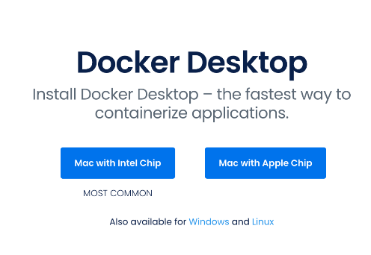

1. **Double-click the Docker.dmg file in your Downloads**
2. **Drag and drop the Docker icon to the Applications folder**

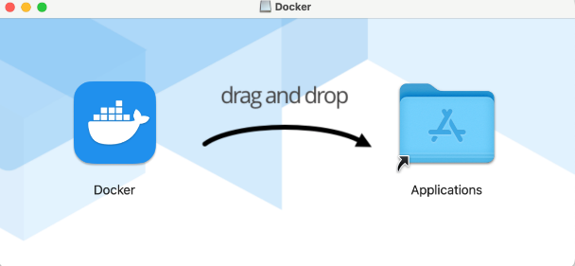

1. **Go to Applications and double-click click the Docker icon:**

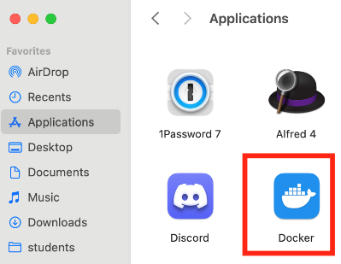

1. **Select "Open" in the "Are you Sure you want to open it" prompt**

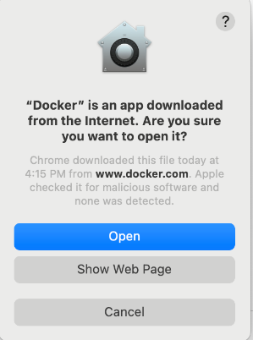

1. **Click "Accept" to the Service Agreement**



1. **Click "OK" to "Docker Desktop needs privileged access" prompt**

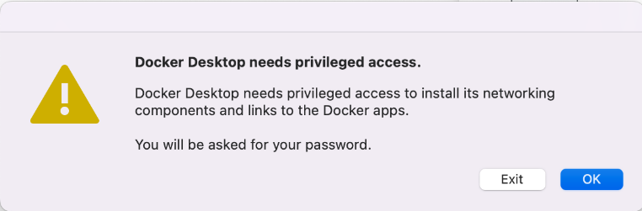

1. **Enter your computer's username and password to install the helper**

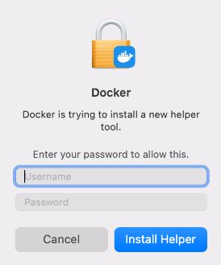

1. **Docker Desktop will launch for the first time**

If the installation was successful, Docker Desktop will launch and present you with a tutorial. You are free to skip this.

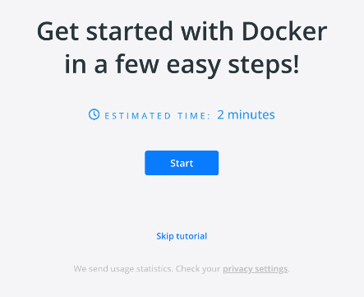

1. **Check that Docker is working**

Open your Terminal application and run the docker command. If all is well you should see some helpful instructions in the output similar to below.

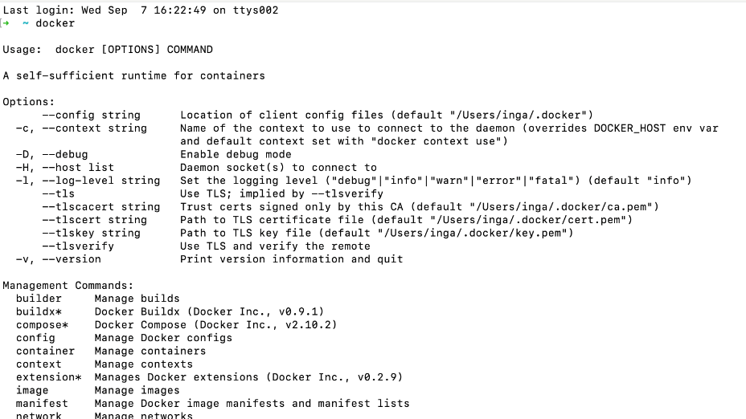

1. **Log in to Docker**

Using your Terminal Application run the docker login command. You will be prompted to enter the Username and password (or your Personal Access Token) you created in step #1 when registering for a DockerHub account.

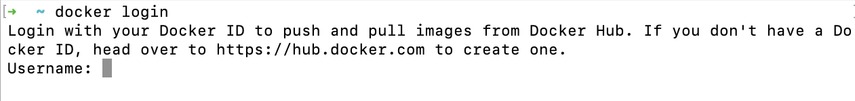

Once you see **Login Succeeded**, the setup is complete and you are free to continue to the next lecture.

Resources for this lecture

* DockerHub Registration
* Docker Desktop Install Link

# **Installing Docker with WSL2 on Windows 10/11**

This note will provide detailed steps and instructions to install Docker and signup for a DockerHub account on **Windows**with**WSL2**. We will need a DockerHub account so that we can pull images and push the images we will build.

Windows 10 & 11 users will be able to install Docker Desktop if their computer supports the Windows Subsystem for Linux (WSL2).

1. **Register for a DockerHub account**

Visit the link below to register for a DockerHub account (this is free)

<https://hub.docker.com/signup>

1. **Download and install all pending Windows OS updates**
2. **Run the WSL install script**

Note - If you have previously enabled WSL you may skip to **step #6**

Open PowerShell as Administrator and run the wsl --install command. This will enable and install all required features as well as install Ubuntu.

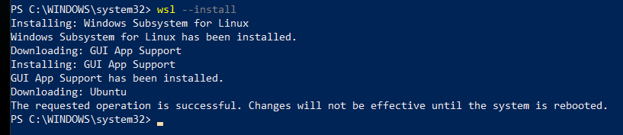

Official documentation:

<https://docs.microsoft.com/en-us/windows/wsl/install#install-wsl-command>

1. **Reboot your computer**
2. **Set a Username and Password in Ubuntu**

After the reboot, Windows will auto-launch your new Ubuntu OS and prompt you to set a username and password.

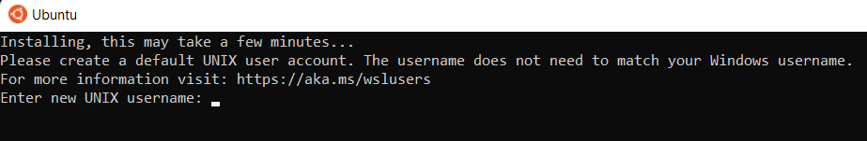

1. **Install Docker Desktop**

Navigate to the Docker Desktop installation page and click the Docker Desktop for Windows button:

<https://docs.docker.com/desktop/install/windows-install/>

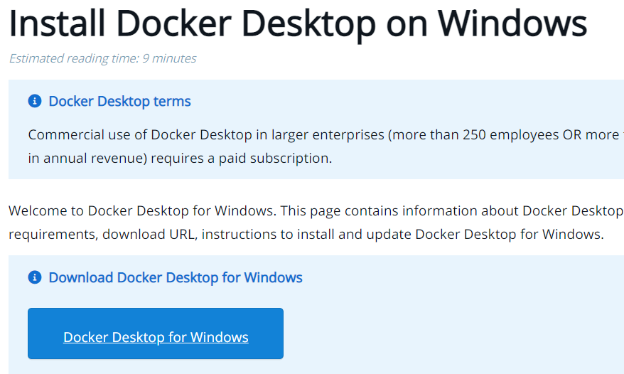

1. **Double-click the Docker Desktop Installer from your Downloads folder**
2. **Click "Install anyway" if warned the app isn't Microsoft-verified**
3. **Click "OK" to Add a shortcut to the Desktop**

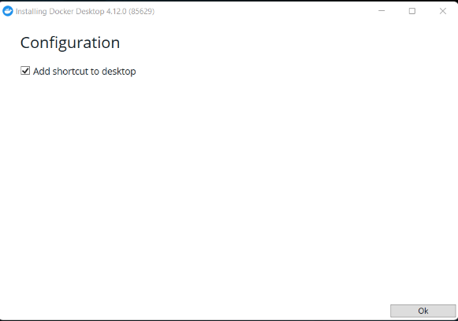

1. **Click "Close" when you see Installation succeeded message**

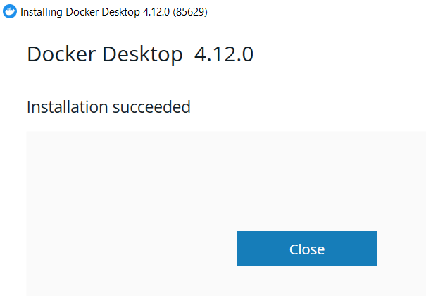

1. **Double-click the Docker Desktop icon on your Desktop**
2. **Accept the Docker Service Agreement**



1. **Docker Desktop will launch for the first time**

Docker Desktop will launch and present you with a tutorial. You are free to skip this.

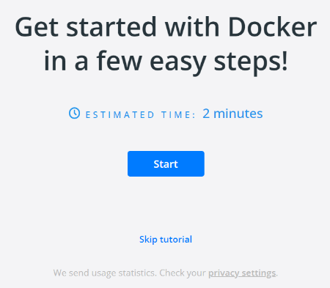

1. **Open the WSL terminal**

Using the Windows Search feature in the toolbar, type **wsl** and click **Open**

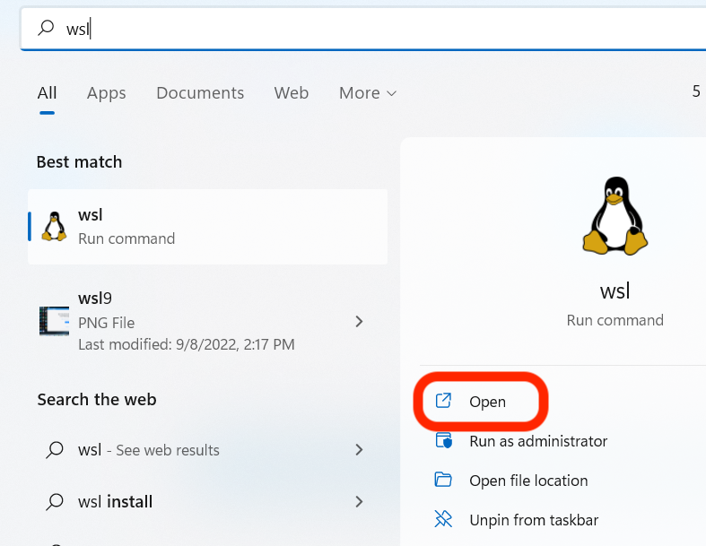

1. **Check that Docker is working**

Using the WSL terminal, run the docker command. If all is well, you should see some helpful instructions in the output like below.

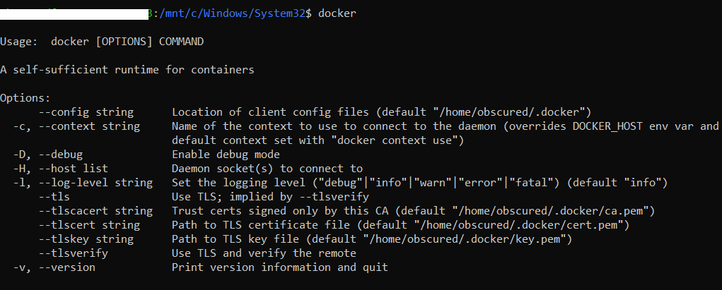

1. **Log in to Docker**

Using the WSL terminal run the docker login command. You will be prompted to enter the username and password (or your Personal Access Token) you created earlier when registering for a DockerHub account.



Once you see **Login Succeeded**, the setup is complete and you are free to continue to the next lecture.

**Appendix**

A significant difference when using WSL is that you will need to create and run your project files from within the Linux filesystem, not the Windows filesystem. This will be very important in later lectures when we cover volumes.

You can access your Linux system by running wsl in the Windows Search Bar. The **wsl** terminal will automatically open to the **/mnt/c/Windows/System32** location. This is still the Windows filesystem! You will need to run the cd ~ command to change into your Ubuntu user's home directory on the Linux filesystem.

Going forward, all Docker commands should be run within **WSL** and not on the Windows file system

Resources for this

* [WSL2 Installation Docs](https://learn.microsoft.com/en-us/windows/wsl/install)
* [Docker Desktop For Windows link](https://docs.docker.com/desktop/install/windows-install/)

# **Installing Docker on Linux**

These steps listed below are for Ubuntu Desktop LTS. You can find the full official docs and steps for other Linux distributions here:

**Ubuntu**: <https://docs.docker.com/install/linux/docker-ce/ubuntu/>

**CentOS**: <https://docs.docker.com/install/linux/docker-ce/centos/>  
(Note: Students have encountered issues when using CentOS or RHEL as the host related to Docker container communication. You may need to research some workaround for the errors you run into or search the QA for already posted solutions)

**Debian**: <https://docs.docker.com/install/linux/docker-ce/debian/>

**Installation Steps**

1. **Create Dockerhub account**<https://hub.docker.com/signup>
2. **Install Docker**The Docker docs suggest setting up a Docker repository to install and update from.  
   This is where you should start: <https://docs.docker.com/engine/install/ubuntu/#install-using-the-repository>
3. **Login to the Dockerhub**In order to push and pull images, you will need to login to the Dockerhub. In your terminal, run docker login and then enter your Dockerhub account's username and password.
4. **Test Docker installation**After completing the installation steps, test out Docker by running sudo docker run hello-world. This should download and run the test container printing "hello world" to your console.
5. **Installing Docker Compose**Navigate to the installation page:  
   <https://docs.docker.com/compose/install/#install-compose-as-standalone-binary-on-linux-systems>  
   Click the Linux Standalone Binary Tab:

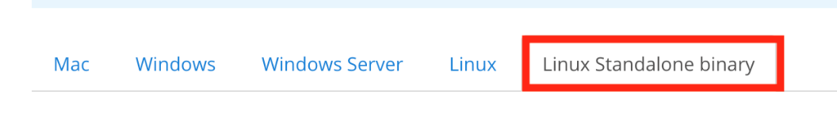

Then, CTL+F to search for the **Install Compose as standalone binary on Linux systems**section on the page**.**Follow the instructions provided there to install the latest Docker Compose binary.

1. **Testing Docker Compose**  
   After completing, test your installation by running docker-compose -v. This should print the version and build numbers to your console.
2. **Run without Sudo**  
   Follow these instructions to run Docker commands without sudo:  
   <https://docs.docker.com/install/linux/linux-postinstall/#manage-docker-as-a-non-root-user>
3. **Start on Boot**Follow these instructions so that Docker and its services start automatically on boot:  
   <https://docs.docker.com/install/linux/linux-postinstall/#configure-docker-to-start-on-boot>

You may need to restart your system.

# **Docker Client**

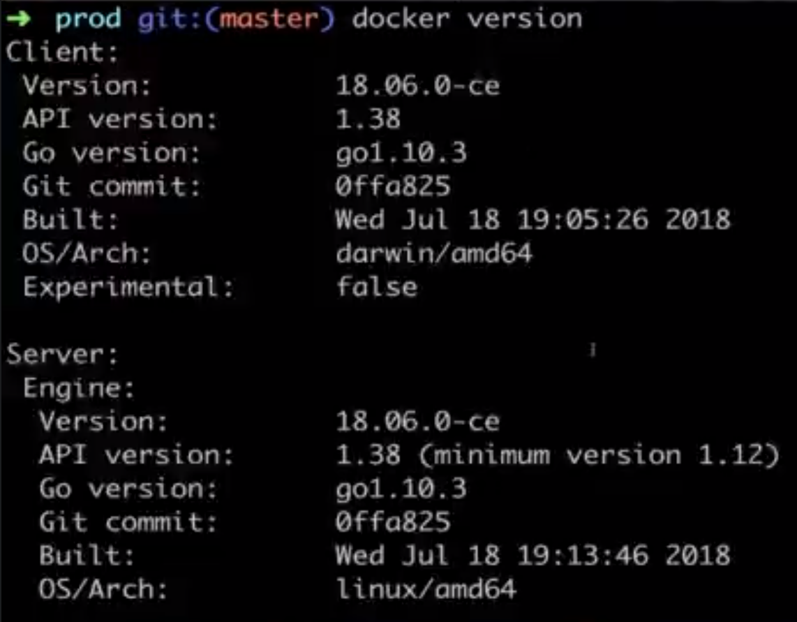

our very first kind of meaningful command with the Docker client or the Docker CLI.

We're going to run a very quick command here,

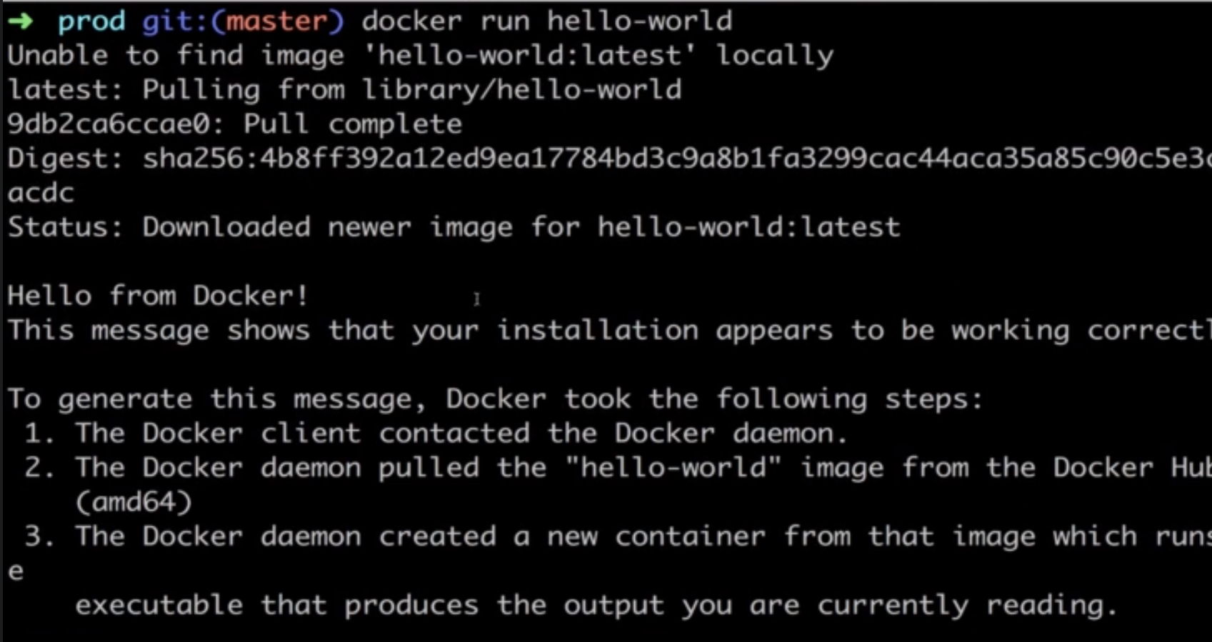

Flow of “docker run hello-world” command

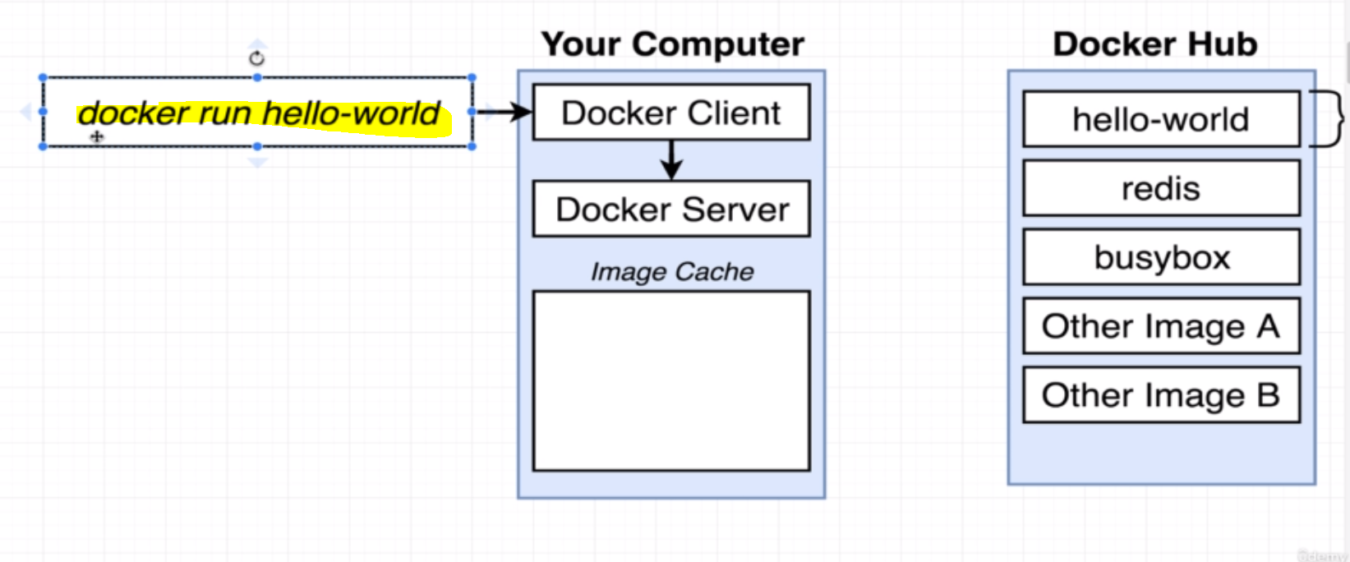

* So, at the Terminal, we executed the command, “docker run hello-world”, That starts up that Docker client or the Docker CLI.
* Again, the Docker CLI oversees taking commands from you, kind of doing a little bit of processing on them, and then communicating the commands over to something called the Docker server.
* it's that **docker server that is really in charge** of the heavy lifting. **When we ran the command, “docker run hello-world”, that meant that we wanted to start up a new container using the image with the name of hello world.**

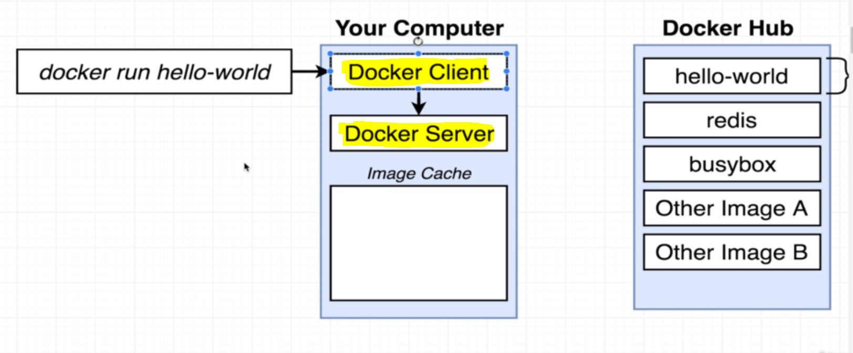

* The hello world image has a tiny little program inside of it whose sole job is issue print-out the message that you see right here.

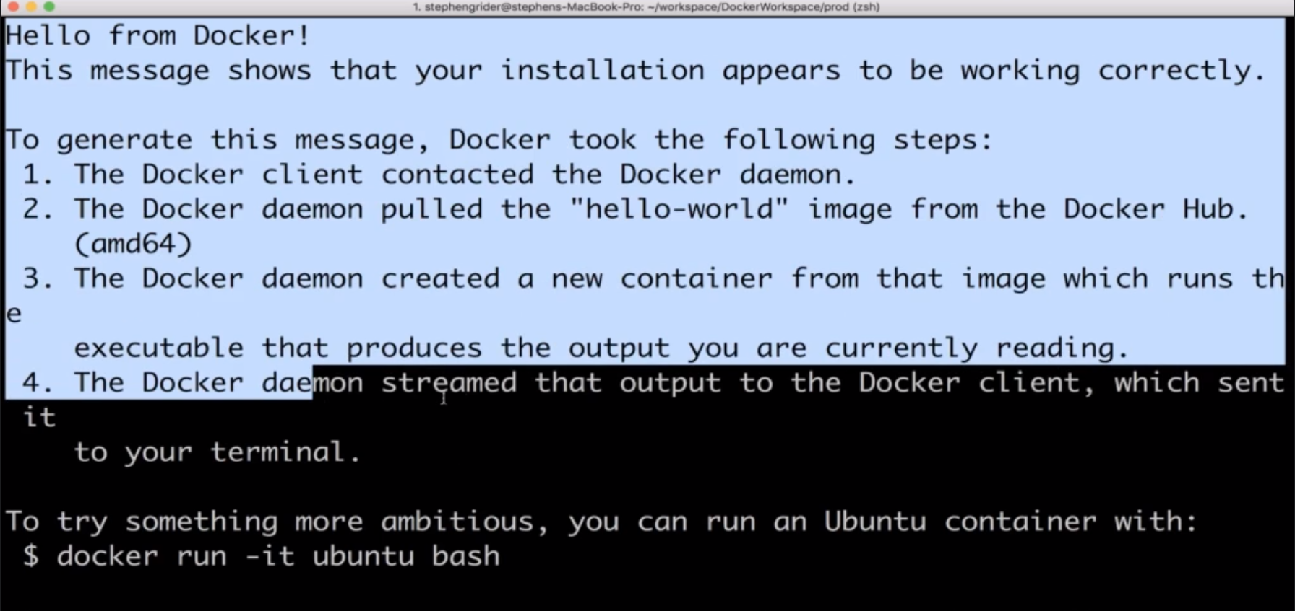

* Now, when we ran that command and it was issued over to the Docker server, a series of actions very quickly occurred in the background.
* The Docker server saw that we were trying to start up a new container using an image called hello world.
* The first thing that the Docker server did was check to see if it already had a **local copy**. Like a copy on your personal machine of the hello world image or that hello world file.
* So, the Docker server investigated something called the **Image Cache**.

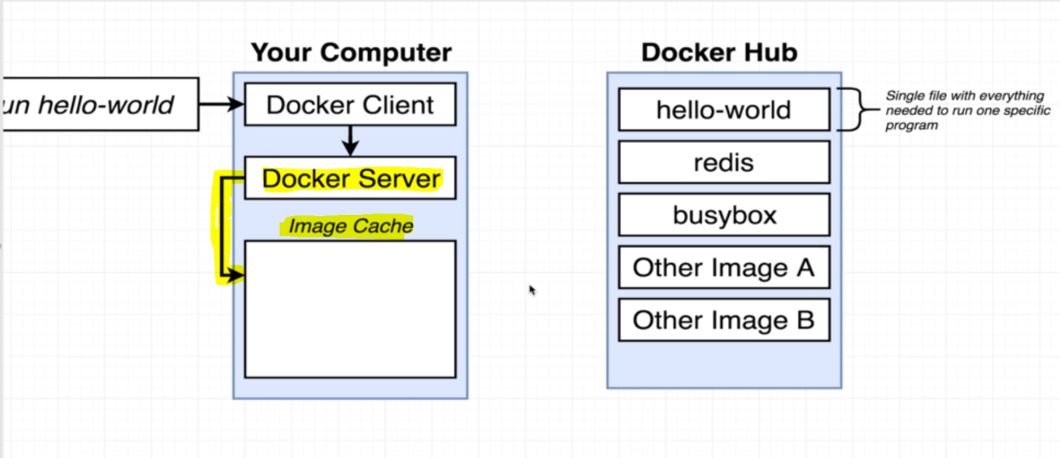

* Now, because you and I just installed Docker on our personal computers the **Image Cache is currently empty**. We have no images that have already been downloaded before.
* So, because the Image Cache was empty, the Docker server decided to **reach out to a free service called Docker Hub**.
* The Docker Hub is a repository of free public images so you can freely download and run on your personal computer.

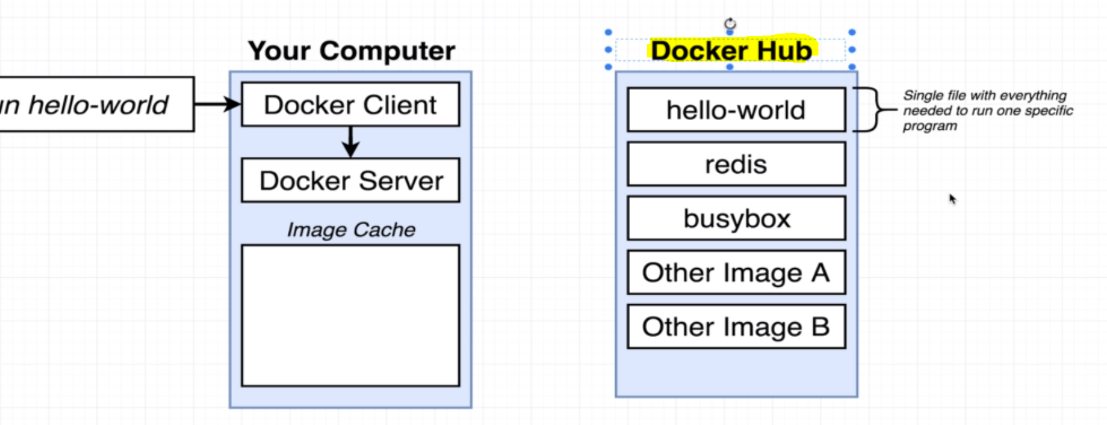

* So, Docker server reached out to Docker Hub and said, **"Hey, I'm looking for an image called hello world. Do you have one?"** Of course, the Docker hub does.

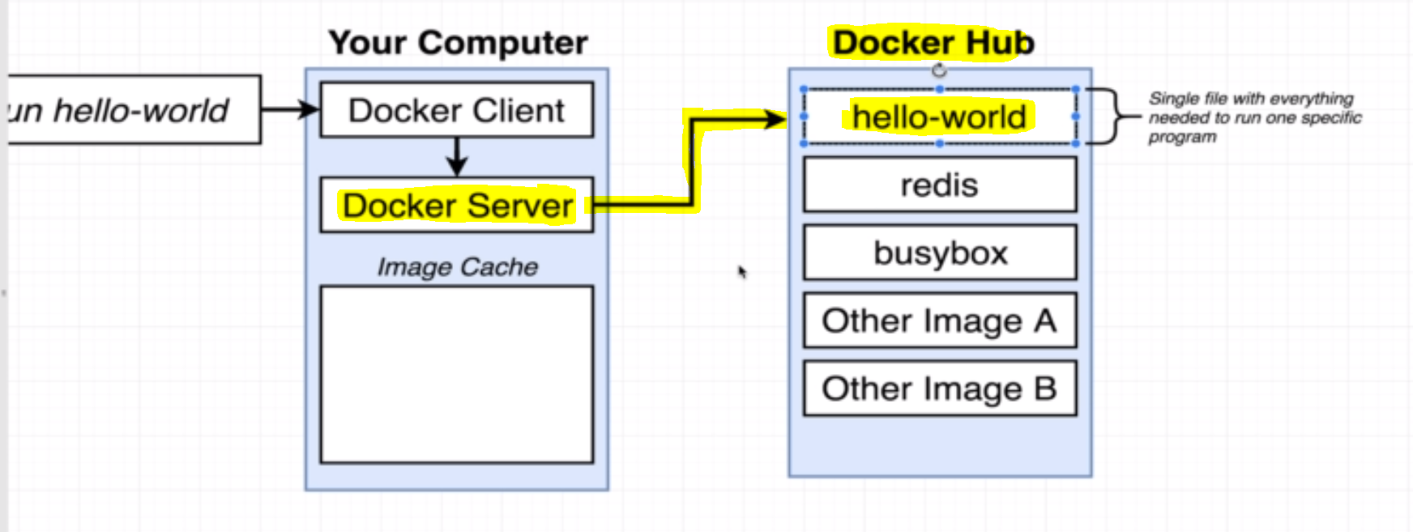

* So, **Docker server downloaded this hello world file and stored it on your personal computer in this Image Cache** where it can now be rerun at some point in the future very quickly without having to re-download it from the Docker Hub.

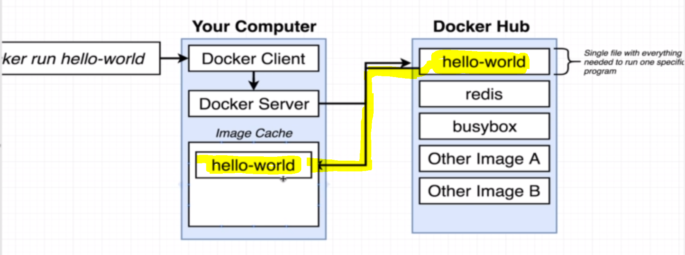

* After that, the Docker server then said, **"Okay, great. I've got this image and now, it's time to use it to create an instance of a container."**
* what we just said about a container a moment ago, *“An instant container is an instance of an image”* **Its sole purpose is to run one very specific program**.

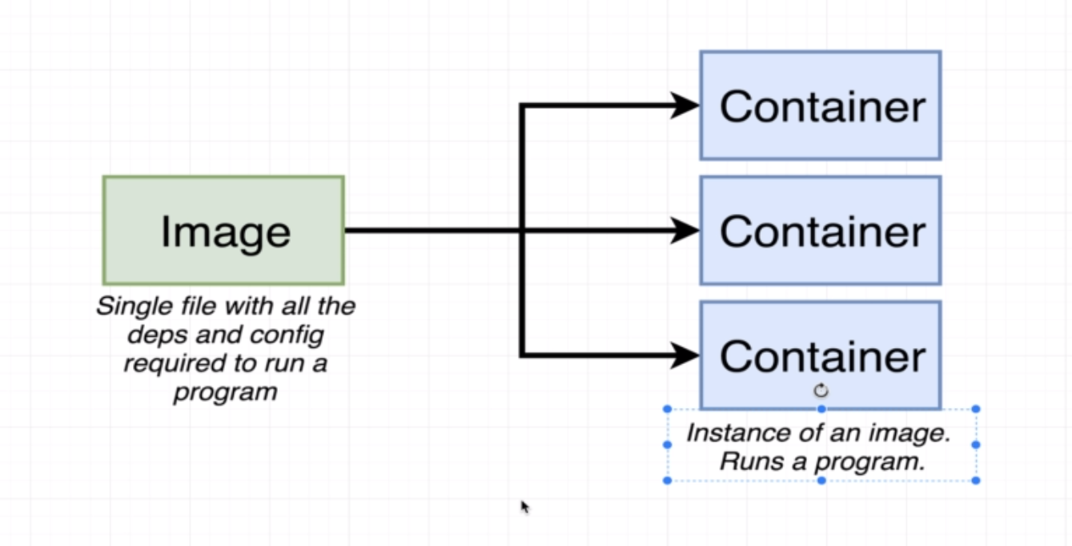

* So, the Docker server then essentially took that single file, loaded it up into memory, created a container out of it, and then ran a single program inside of it.
* And that single program's purpose was to print out the message that you see right here.

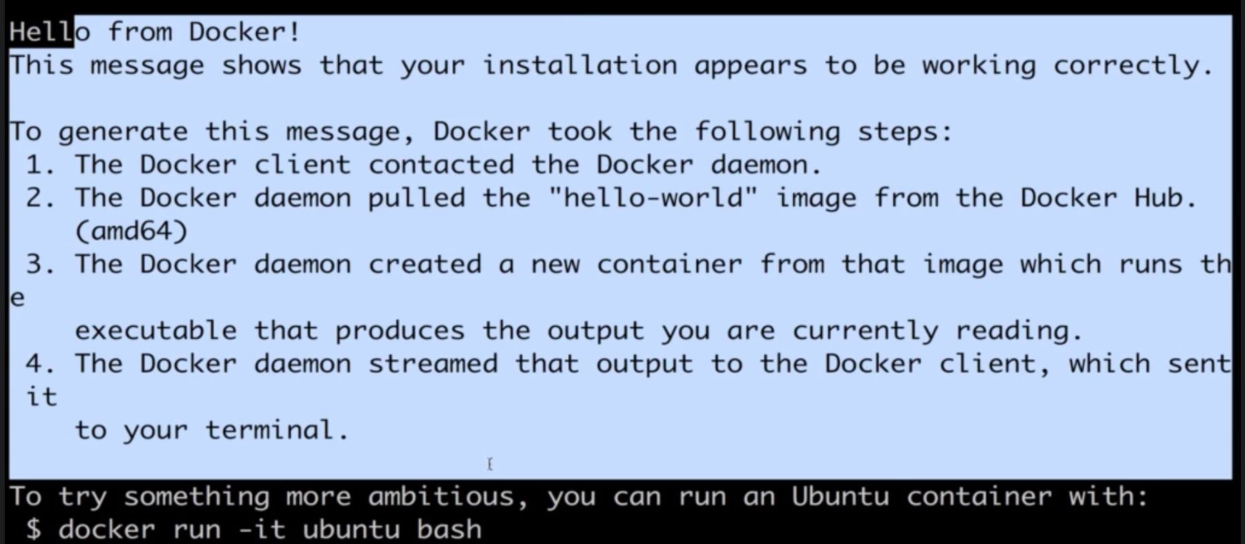

So, that's pretty much it. That's what happens when you run this Docker run command.

* It reaches out to Docker Hub.
* it grabs the image.
* then it creates a container out of that image.
* Now, one thing that you'll notice that's kind of interesting if we run the docker run hello-world command a second time, you'll notice that we are not going to see the message of downloading or container image not found locally that we saw the first time.

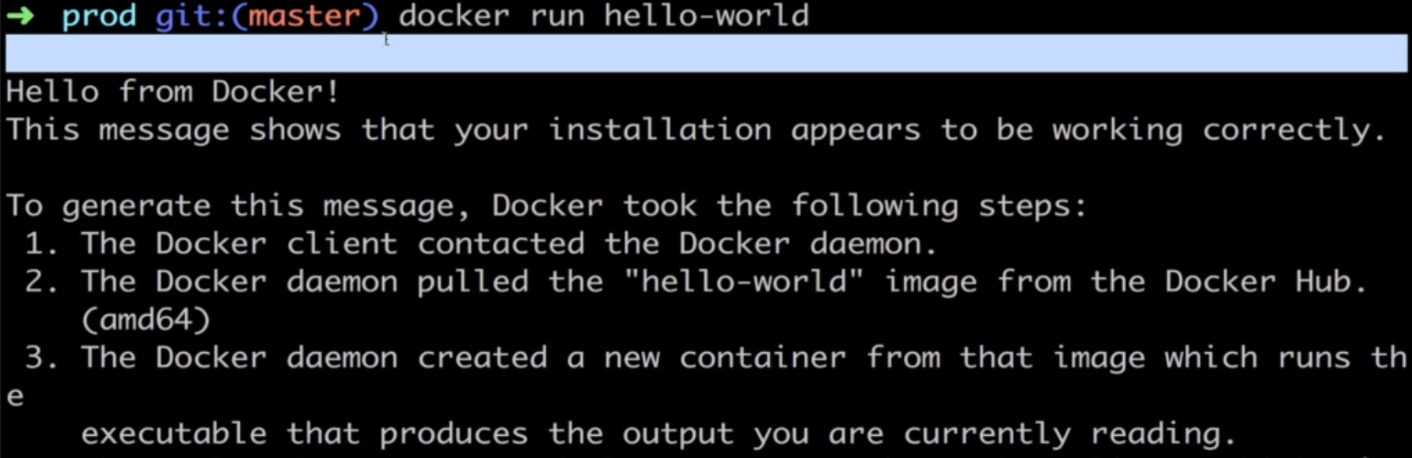

* So, scroll back up to the very top. Here's the first time that we ran the command. You'll notice it up here it said, "Unable to find image locally."

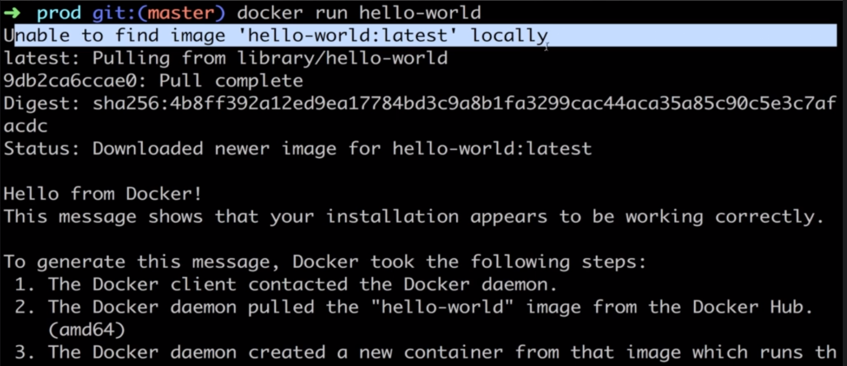

* But now the second time, we did not see that message and that is because we already downloaded it to our Image Cache on our personal computer.

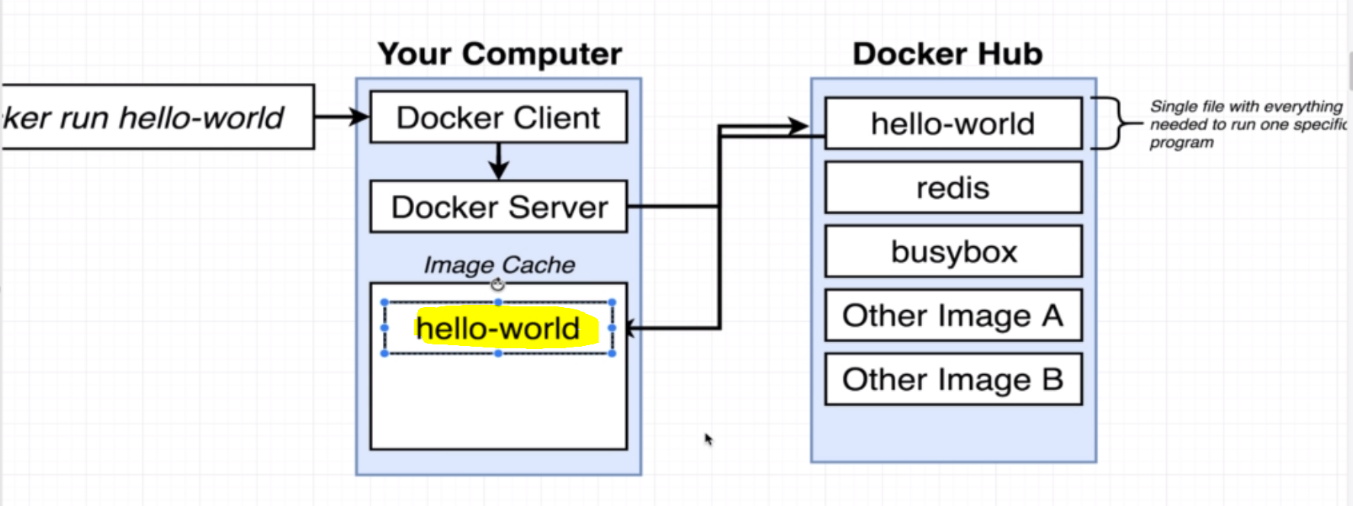

* So, the big lesson here is that the first time that you try to make use of any of these public images over here, you're going to do a little bit of a download. But then in the future after that, you can start up a container using that image much more quickly because the image has already been downloaded to your computer.